W04 Learning Activity: Foundation Review

Overview
Now that you have learned the first two principles of Programming with Classes, this week will help you reinforce these principles and Firm up your Foundation by by practicing each principle in small projects.

Your Programming Foundation
In Matthew Chapter 7, Jesus taught:
24 Therefore whosoever heareth these sayings of mine, and doeth them, I will liken him unto a wise man, which built his house upon a rock:
25 And the rain descended, and the floods came, and the winds blew, and beat upon that house; and it fell not: for it was founded upon a rock.
In a similar way, it is critical to make sure your programming skills are built upon a rock or a sure foundation, so that as you learn more advanced topics, you will have the proper foundation of core knowledge for it to stand upon.
In some courses, you learn about many independent ideas, and it's ok if you don't understand some of them deeply the first time you go through the material. In programming, however, each new topic builds directly on the previous concepts, so it's important to make sure you have a solid foundation of each one before moving on to the next.
With this in mind, rather than introducing a new topic, this lesson will help you practice and firm up the foundation of the previous lessons.

Getting Caught Up
If you have gotten behind, missed an assignment from the previous two weeks, or didn't understand a previous assignment as well as you would have liked, take the time this week to get caught up.
Make sure to submit any missing assignments or to fix and resubmit any that you didn't understand well enough.

Foundation Programming Assignments
This lesson will have two programs to complete. They are designed to be fairly concrete and will help you strengthen your understanding of the core principles and the mechanics of using them in programming.
These foundation programs are different than the standard projects in the course. They will be smaller than the standard projects, and likely require less time. They will not have a user interface component and there is not expectation for you to show creativity and go above and beyond the core requirements.

Learning Activity Instructions
There is no new material to study for this week. Instead, please review the learning activities from the previous weeks:
- Week 02 Learning Activity: Abstraction
- Week 03 Learning Activity: Encapsulation
When you feel comfortable with these topics, there is a quiz for this learning activity where you can demonstrate your understanding.

Submission
- Return to Canvas and take the associated quiz.

W02 Learning Activity: Abstraction

Overview
In this activity you will learn and practice the principle of Abstraction.

Prepare

What is Abstraction?
Abstraction is the process of turning complex ideas into simple ones. It is removing characteristics from something so that only the essential ones remain. As programmers, we create and use abstractions all the time. Consider the following line of Python code.

print("hello world")

Whether or not you're familiar with Python, you probably recognize this as the first program we all learn to write. You also probably understand this statement will show the words, "hello world", on a computer display. However, relatively few programmers know the details of how this is accomplished. As it turns out, it takes over 3000 lines of C to implement this function.
The print function in Python is an abstraction. It is the simplification of something that is actually quite complex. In order to use it, all we need to know is the function name itself, or "print", and the required arguments, some literal text or a variable that can be transformed into literal text.
The print function might be used within another function we write to create yet another abstraction. That is, a different function that simplifies a higher order idea or task. This layering of abstractions is exactly how all of the software used in the world today, from text editors like Notepad to social media platforms like Facebook, is written.

Objects and Classes
Programming with classes is another way of creating abstractions in software. We begin, however, by thinking about objects. An object is a conceptual model for a category of things, real or imagined, that has a specific responsibility within our program. For example, we might think of an object that holds and provides identifying information about a person.
Objects have state and behavior that allow them to fulfill their responsibility. The person object may have state like "given name" and "family name". It may also have related behaviors like "show western name" (given name first) and "show eastern name" (given name last). Following is a graphical depiction of our person object.
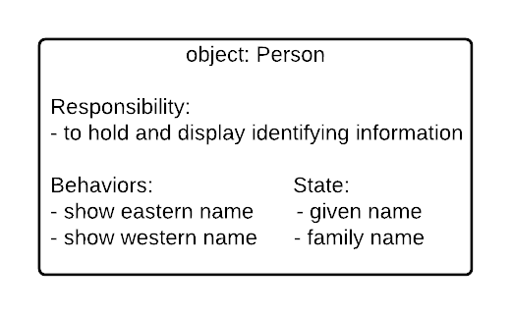Person Responsibilities
Thinking about a person this way is an abstraction. It is a simplification of something that is more complex. It might seem trivial at first but not having to worry about differences in lexical name form anywhere else in our software is significant. We can just rely on the person object to take care of it.
There aren't any unrelated behaviors either. There are certainly many other ones we could think of as belonging to a person. However, our conceptualization only contains those that help fulfill its specific responsibility.
With an object in mind we are ready to translate it to a code template called a class. The object's state is translated to variables called attributes. The object's behaviors are translated to functions called methods.
As a stepping stone to writing the actual code, we can create a Class Diagram which is a box that has the name of the class at the top, the member variables or attributes in the middle, and the methods at the bottom. Member variables are followed by a colon and their data type, and methods are followed by a colon and their return type. The following is an example of the Class Diagram for the Person class described above:
Person Class Diagram
You can observe from the class diagram that the standard in C# is to use TitleCase for class and method names, and to use _underscoreCamelCase for our member variable names. The underscore at the beginning helps you recognize that the variables are members of the class and are different from regular, local variables.
Once we have a class diagram, we have enough detail to begin to implement the class in code. The following is an example of the Person translated to a class in code. Be sure to read all of the comments and code carefully.

// A code template for the category of things known as Person. The
// responsibility of a Person is to hold and display personal information.
public class Person
{
// The C# convention is to start member variables with an underscore _
public string _givenName = "";
public string _familyName = "";

// A special method, called a constructor that is invoked using the
// new keyword followed by the class name and parentheses.
public Person()
{
}

// A method that displays the person's full name as used in eastern
// countries or <family name, given name>.
public void ShowEasternName()
{
Console.WriteLine($"{_familyName}, {_givenName}");
}

// A method that displays the person's full name as used in western
// countries or <given name family name>.
public void ShowWesternName()
{
Console.WriteLine($"{_givenName} {_familyName}");
}
}

Classes and Files
To make it easy to find classes, the standard for C#, and many other languages, is to put each public class in its own file. The name of this file should exactly match the class name, including capitalization, and then it should have an extension of .cs for C Sharp.
For example, the Person class should be in Person.cs. Similarly, a Book class should be found in Book.cs, an IllustratedComicBook class should be found in IllustratedComicBook.cs, and so forth.

A Note on Creating Diagrams
There are many tools to help you create class diagrams, and as you learn about more details of programming with classes you will learn that there are lots of elements that can be added to a diagram.
For this course, the important part is to focus on the name, the attributes (member variables), and the behaviors (methods). If you would like to find and use a tool to create the diagrams, that is great, but you can also do this as simply as creating a bulleted list in any text editor:

Class: Person
Attributes:
* _givenName : string
* _familyName : string

Behaviors:
* ShowEasternName() : void
* ShowWesternName() : void

Classes and Instances
By itself, a class is just a template for something. It only becomes useful when an instance is created and assigned to a variable in your program. An instance is the realization of attributes and methods in the computer's memory.
Another way to think about creating an instance of a class is to imagine baking a cake. In this metaphor, a class is like the recipe. It is a template for a cake but not the actual baked good. In contrast, an instance is what comes out of the oven. It is a realization of the recipe details in a sweet tasting crumb! Consider the following code.

Person person = new Person();
person._givenName = "Joseph";
person._familyName = "Smith";
person.ShowWesternName();
person.ShowEasternName();

Output:

Joseph Smith
Smith, Joseph

In this example, an instance of the Person class is created and assigned to the variable called "person". It is created by invoking a special method, called the constructor, which is the name of the class followed by parentheses. Some programming languages, like Java, C# and others, require the "new" keyword when calling a constructor. (You will learn more about constructors in the next unit.)
One of the most important aspects of programming with classes is that multiple instances can be created and used in the same program. The following example shows the creation of two Person instances. Notice how the "given name" attributes are assigned different values, varying the behavior of the "show western name" method from one instance to the other.

person1 = new Person();
person1._givenName = "Emma";
person1._familyName = "Smith";
person1.ShowWesternName();

person2 = new Person();
person2._givenName = "Joseph";
person2._familyName = "Smith";
person2.ShowWesternName();

Output:

Emma Smith
Joseph Smith

Custom Data Types
When you create classes, you are really creating a new custom data type. For example, in C# there are built-in data types for integers and strings. When you declare a variable of these types, it is like making a box that can hold that type of data, and putting a label on the outside of the box with the variable name. For example, consider the following code:
int height;string color;
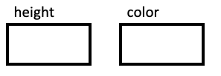
This code creates boxes that you can later fill with values. Then, when you assign the value, it puts it in the box. For example, the following code puts the number 17 in the box:

height = 17;
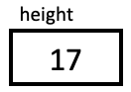
And this code, changes it to 24:

height = 24;
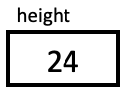
Now suppose you were working for a window covering company that manufactured blinds, and you wanted a program to work with these blinds. Your code would need to store the width, height, and color of each blind in the program.
Imagine how great it would be if C# came with a data type like string or int but that was designed specifically with blinds in mind that could store all three of these components together. With classes, we can create this new datatype as follows:
public class Blind
{
public double _width;
public double _height;
public string _color;
}
With this new custom data type, you can now create a new variable whose type is Blind. We can think about this as creating a new box for it. The difference is that this box has a little separator inside it making three smaller compartments, one for each of the three member variables.
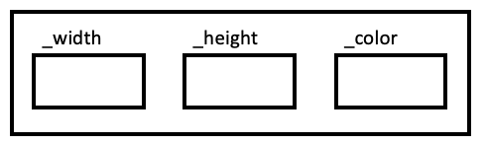
Every time you create a new Blind variable, it creates another large box that has these three components. The class is what defines the structure of the large box, and each of these large boxes that you create is an object or instance of that class.
For example:

Blind kitchen = new Blind();
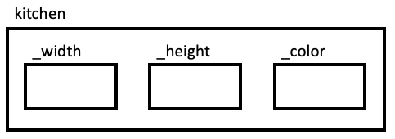
In your code, whenever you use the variable kitchen it refers to a large box, and if you want to refer to anything inside the box, you use the "dot" operator. You can set the values as follows:

kitchen._width = 60;
kitchen._height = 48;
kitchen._color = "white";
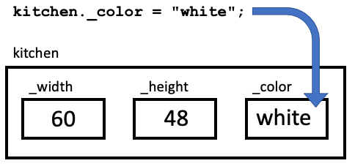
And you can access the values in the same way:

Console.WriteLine(kitchen._width);
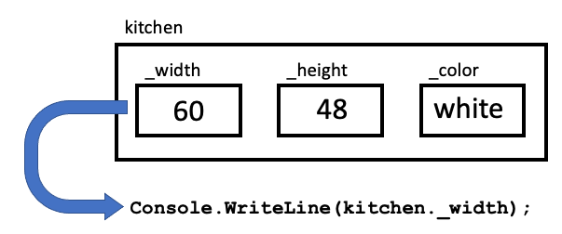
Storing all of these values together in one larger box can greatly simplify your code, because, for example, you can now pass that whole large box to a function as a parameter, or return it.

Adding Behaviors
In addition to storing values together than belong together, you can also put the member functions, or methods, that use that data right in the box with them.
For example, continuing with the same window covering example, suppose that you wanted a method to compute the area of the blind, so the program could display the amount of material you needed. This could be added as a function inside the box, called, GetArea().
public class Blind
{
public double _width;
public double _height;
public string _color;

public double GetArea()
{
return _width * _height;
}
}
The GetArea() function now belongs inside the box as well. And because it is inside the box, you use the "dot" notation to call it:
double materialAmount = kitchen.GetArea();
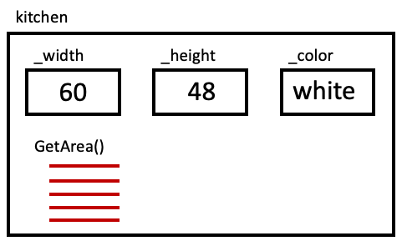
(The red lines in the image are meant to indicate that there are lines of code associated with this method.)
The following shows all of these lines together:

Blind kitchen = new Blind();

kitchen._width = 60;
kitchen._height = 48;
kitchen._color = "White";
double materialAmount = kitchen.GetArea();
Notice that to call the GetArea() method, you must supply the name of the object first, followed by a dot. Then, also notice that you do not need to pass it variables for the width and the height. This is because this method is a member of the class, so it is already "in the box," so it can access any of the member variables it needs.
The fact that the method accesses the member variables in its box, is also why GetArea() will return different values for different Blind objects, such as kitchen.GetArea() and livingRoom.GetArea(), because these two objects will have different values for their widths and heights.
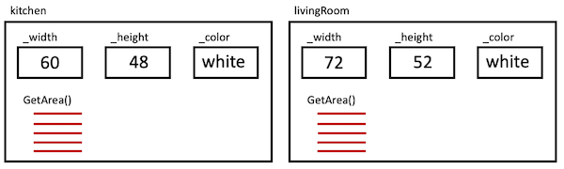

Objects within Objects
In the previous example, all of the member variables had simple types (double or string). But member variables can also have custom types. This is similar to putting another box inside the larger one.
For example, in the window covering example, you might consider creating another class for the whole house. Internally, it might contain other member variables, some of which could be simple types, and others could be complex types. For example:
public class House
{
public string _owner;
public Blind _kitchen;
public Blind _livingRoom;
}
Remember, that you must initialize these blinds to new values. You can do this after you create a new House object:

House johnsonHome = new House();

johnsonHome._kitchen = new Blind();
johnsonHome._livingRoom = new Bind();
Or, you can initialize these variables right in the class definition:
public class House
{
public string _owner = "";
public Blind _kitchen = new Blind();
public Blind _livingRoom = new Blind();
}
Once you have created a new House object, you can access its member variables using the "dot" operator just as before:

House johnsonHome = new House();
johnsonHome._owner = "Johnson Family";
When you want to access the internal values of one of these complex-type, member variables, you can just chain together multiple "dot" operations, such as:

johnsonHome._kitchen._width = 60;
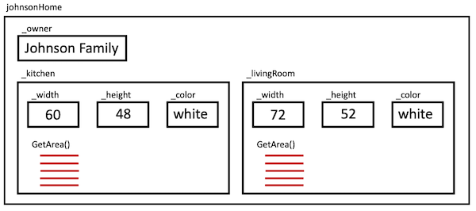

Lists of Custom Types
In the same way that you can create a list of strings or a list of doubles, you can also create a list of a new custom type. For example, instead of the House class containing variables for the kitchen and the living room blinds, it might have a list of blinds:
public class House
{
public string _owner;
public List<Blind> _blinds = new List<Blind>();
}
With this new version of the House class, you could write code like:

johnsonHome._blinds.Add(kitchen);
or:
double amount = johnsonHome._blinds[0].GetArea();
or:
foreach (Blind b in johnsonHome._blinds)
{
double amount = b.GetArea();
}
The following figure shows the way you might think about the storage of the johnsonHome object. Notice that the _blinds member variable now refers to a list of Blind objects. Each Blind object can be referenced by its index, and each has its own values for the _width, _height, and _color variables.
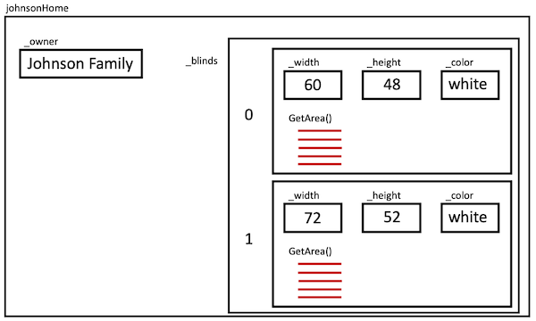

Summary
Think back to the beginning paragraphs in this article. One of the more interesting aspects of abstraction is that we can layer them, as you have just seen, putting objects within objects. Each of these objects can have their own responsibility, behaviors and state.
Abstraction is the first principle of programming with classes. As you get better at applying it, you'll find you're able to think and talk about your software, with programmers and non-programmers alike, in a very natural way. Please don't underestimate the value of this ability. Being able to communicate clearly about what is needed and what you're doing is at the very heart of creating software that is ready for change.

Terms and Definitions
Class - A new custom data type that defines attributes (member variables) and methods. This is like a blueprint to create instances or objects of that class. Example: A Person has given name and family name.
Instance - A variable whose data type is the class. We often use the term Object interchangeably. Example: We can have two instances of the Person class: one for John, and one for Mary.
Instantiate - A verb that means "to create an instance of." Example: We can instantiate the Person class to create a new object.
Method - A member function. Methods are called using "dot notation" with an instance of the class before the dot. Example: person1.GetEasternName()

Activity Instructions
Practice the principle of abstraction by creating classes to represent a resume or job history for a person (like you might see on LinkedIn).

Design the Classes
You program should contain two classes one for a Job and one for the Resume itself, as follows:

Class: Job
- Responsibilities:
  - Keeps track of the company, job title, start year, and end year.
- Behaviors:
  - Displays the job information in the format "Job Title (Company) StartYear-EndYear", for example: "Software Engineer (Microsoft) 2019-2022".

Class: Resume
- Responsibilities:
  - Keeps track of the person's name and a list of their jobs.
- Behaviors:
  - Displays the resume, which shows the name first, followed by displaying each one of the jobs.
Based on these descriptions, you could create class diagrams like the following:
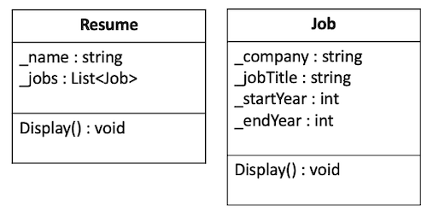Resume and Job Class Diagrams

Start the Project
- Open the class project in VS Code.
- Navigate to the Resumes project in the week02 folder. Find the Program.cs file, which will be your entry point for the program.
- Verify that you can run the project and see the beginning "Hello World" output.

Create the Job class
- Create a new file for your job class. By convention this should be named Job.cs .
- Create the class (Hint this is the public class Job syntax).
- Create member variables in the class for each element that this class should contain. By convention these member variables should begin with an underscore and a lowercase letter such as _jobTitle .

Test your Job class
- Back in your Program.cs file, add code to your Main function.
- Create a new job instance named job1 .
- Set the member variables using the dot notation (for example, job1._jobTitle = "Software Engineer";
- Verify that you can display the company of this job on the screen, again using the dot notation to access the member variable.
- Create a second job, set its variables, display this company on the screen as well.
Sample Output

Microsoft
Apple

Add a Display method to the Job class
- Return to your Job.cs file and add a method (member function) to display the job details. This method should not have any parameters and does not need to return anything. By convention, this method should begin with a capital letter, such as Display, and if you have multiple words each word should be capitalized, such as DisplayJobDetails .
- This method should display the job details on the screen in the correct format. Remember that the method can access the member variables directly, without needing them to be passed into it.
- Return to your Program.cs file. Remove the lines of code where you displayed the company earlier, and replace them with calls to your new method. Remember that you call the method using the same dot notation such as job1.Display(); .
Sample Output

Software Engineer (Microsoft) 2019-2022
Manager (Apple) 2022-2023

Create the Resume class
- Create a new file for your Resume class. Each class should be in its own file and the file name should match the name of the class.
- Create the Resume class.
- Create the member variable for the person's name.
- Create the member variable for the list of Jobs. (Hint: the data type for this should be List<Job> , and it is probably easiest to initialize this to a new list right when you declare it..)

Test your Resume class
- Return to your Program.cs. Add the end of the Main function, create a new instance of the Resume class.
- Add the two jobs you created earlier, to the list of jobs in the resume object.
- Verify that you can access and display the first job title using dot notation similar to myResume._jobs[0]._jobTitle .

Add a Display method to the Resume class
- Return to your Resume class and add a method to display its details.
- This method should not have any parameters and should not return anything.
- In the method body, you should display the person's name and then iterate through each Job instance in the list of jobs and display them.
- Hint: remember that you can call each job's Display method that you created earlier.
- Return to your main function, remove any code that is displaying information, and instead, add a call at the end to the Display method from your Resume class to display the name and all the jobs in one line.
Sample Output

Name: Allison Rose
Jobs:
Software Engineer (Microsoft) 2019-2022
Manager (Apple) 2022-2023

Sample Solution
When you have finished please compare your approach to the following sample solution (you may also use this sample solution as a guide if you need help finishing).

https://github.com/byui-cse/cse210-ww-student-sample-solutions

W03 Learning Activity: Encapsulation

Overview
In this activity you will learn and practice the principle of Encapsulation.

Prepare
Encapsulation is the act of enclosing something, as if it were in a capsule. It means thinking carefully about the behaviors your classes need and then hiding the details of how they perform those behaviors, even making it so other code cannot see or manipulate these details.
Previously, you learned about the power and value of abstraction in writing programs that can handle change. One of the main principles was to let a class be responsible for the details of a particular task. Then, the other parts of the program do not have to worry about those details, as long as they know how to interact with the class itself.
With encapsulation, we push this idea further by preventing other parts of the program from accessing those details. The idea is that a class should completely encapsulate, or contain, all of the data and logic surrounding the task. If other parts of the program need to perform the task or something related to it, they should not try to access the data directly. Instead, they should communicate with the class in question, and it can access the data as necessary. If the class has well-designed methods, other parts of the program shouldn't need direct access to the internal data, they can rely on the methods provided.
In this way, a major component encapsulation in programming involves information hiding or controlling access to internal data.

Why Encapsulation Matters
At first glance, it may seem a little silly to hide information or restrict access to parts of the code from other places of the program, but it turns out to be critical for two main reasons:
- If something is broken, any code that has access might be to blame.
- If something needs to change, any code that has access might need to change.
Consider the following code.
public class Account
{
public int _balance = 0;

public void Deposit(int amount)
{
_balance = _balance + amount;
}
}

Account savings = new Account();
savings._balance = 50;
savings.Deposit(100);
What would happen if we decided to change the balance attribute in the Account class to a list of transactions? On one hand, we'd be able to keep track of individual deposits. On the other hand, we'd break a different part of the program.
public class Account
{
public List<int> _transactions = new List<int>(); // if we change this to a list...

public void Deposit(int amount)
{
_transactions.Add(amount);
}
}

Account savings = new Account();
savings._balance = 50; // if we make the change above, this doesn't work anymore!
savings.Deposit(100); // however, this approach would continue to work
In this case, the details of the Account class are not well encapsulated. We need a way of hiding the class attributes so that other code does not attempt to change them directly. If we can, it will allow us to minimize the interdependencies between different parts of our code and protect them from breaking changes.

Video Example
Please watch the following video that highlights this example of Encapsulation.
Direct Link: Encapsulation (6 minutes)

Using Access Modifiers
Some programming languages, like C#, use access modifiers, or special keywords, to specify which attributes and methods are public or private. Public class members are accessible from anywhere in the program. Private class members are only accessible by methods in the class that contains them. Other languages, like Python, use coding conventions to indicate how a class member should be treated.
In C#, Any class members that should be kept private or hidden from other parts of the program should begin with the private keyword. Any class members that should be available for use in other parts of the program should begin with the public keyword. These are called access modifiers.
public class Account
{
private List<int> _transactions = new List<int>();

public void Deposit(int amount)
{
_transactions.Add(amount);
}
}
Sometimes it's difficult to decide what class members should be public or private. A good rule of thumb is to restrict access to class members as much as possible.

Hiding information from who?
Keep in mind that when we talk about making data private or hiding it, we are not talking about encrypting sensitive data like credit card numbers to hide it from the user or from hackers. Instead, we are limiting the parts of our program than can directly access a variable. So we are hiding it from ourselves in other parts of the program.
The idea is to limit access to only those parts of the code they really need it.

Attributes
As a general rule, attributes (or member variables) should be made private. Other classes should not know the details of how the class stores its information. Instead, the other parts of the program should ask the class to perform tasks related to that information through public methods.
The following example shows how to declare private member variables:
public class Person
{
private string _title;
private string _firstName;
private string _lastName;

...
}

Methods
Many methods (or member functions) of a class are public. This is the interface that other parts of the program can use to perform the tasks they need.
Are there ever private methods? Yes! Often, a public method will have internal steps or computations to perform to help it do its job. These "helper functions" are often private, because the only code that needs to access them is in the class.
As stated above, the general rule to follow is: restrict access as much as possible. Only make an attribute or method public if there is a specific need.

Example
The following example shows how to declare public and private member functions. It gives examples of getting two kinds of email signatures, one that is formal ("Sincerely"), and one that is informal ("Thanks"). The formal one makes use of the person's full name.
In order to get the full name from a class that stores the first and last names separately, the class might make use of a private, helper function to prepare the full name. This function could be made private initially, because others only need access to the email signature. (If it is later determined that others need access to the full name itself, you could consider making it public as well. But in all cases you are keeping the variables private.)
public class Person
{
private string _title;
private string _firstName;
private string _lastName;

public string GetInformalSignature()
{
return "Thanks, " + _firstName;
}

public string GetFormalSignature()
{
return "Sincerely, " + GetFullName();
}

private string GetFullName()
{
return _title + " " + _firstName + " " + _lastName;
}
...
}

Getters and Setters
Sometimes you may feel that other parts of the program need access to a member variable. If this is the case, instead of making the variable public, you should create methods to get and set the value. This ensures that the class still controls access to the variables and that the variables themselves are hidden.
These functions are called "getters" and "setters" or accessors and mutators, and they are very common.
The following example shows how to create a getter and setter for the _firstName variable:
public class Person
{
private string _title;
private string _firstName;
private string _lastName;

public string GetFirstName()
{
return _firstName;
}

public void SetFirstName(string firstName)
{
_firstName = firstName;
}

...
}
This would then be called from another part of the program as follows:

Person p = new Person();
p.SetFirstName("Peter");

Console.WriteLine(p.GetFirstName());
Notice that the other part of the program now has the ability to set the first name, and can also access it when needed, but it does so by calling these methods, rather than interacting with the variables directly.

On Getters and Setters
Getters and setters are so common that many well known code editors will automatically generate them for you. But they have also been the subject of debate since at least 2003 when Allen Holub published an article called, Why Getter and Setter Methods Are Evil.
While we encourage you to develop your own opinion we think Mr. Holub's advice is sound. When you're programming with classes, focus on what the class must do rather than how it will do it and many of the getters and setters in your code will naturally disappear. You simply won't have to worry about it.

C# Properties
Because the notion of getters and setters is so powerful and so common, some languages, including C#, have created a special language construct for them called, properties. These properties allow you to create getters and setters that behave like methods, but can be used more like a variable. You may see the syntax for these properties in code on the internet in a manner such as public int Age { get; set; }.
In this course, we have deliberately decided to avoid teaching and using these properties for two reasons. First, they are not available in all languages. And second, they can cause confusion as you are just getting started and give you the wrong mental model, because of the way they blur the line between methods and variables. They almost start to feel like magic, and give the impression that this is a good way to make public member variables, and then you lose the very principle of encapsulation.
For all these reasons, as you get started with getters and setters, you are encouraged to use the actual getter and setter methods. Then, as you get more comfortable with them, it will be an easy switch for you to begin using properties.

Constructors
In the previous lesson you were introduced to Constructors. Constructors are special methods that are called automatically when an object is created. Their purpose is to help set up the initial state of an object. The name of a constructor must match the class name, and the return type is left empty (not even void). The simplest constructor is a no-argument constructor, that allows an object to be created without specifying any extra information.

Person p = new Person(); // This calls a no-argument constructor and doesn't need any information
You can use this constructor to help set default values. For example, the following code specifies a no-argument constructor to set a default name for all new Person objects that are created.
public class Person
{
private string _title;
private string _firstName;
private string _lastName;

public Person()
{
_title = "";
_firstName = "Anonymous";
_lastName = "Unknown";
}

...

}
In addition to a no-argument constructor you might want to have another one to allow the user to pass in the values for some of the member variables. For example, the following code shows a class with three constructors, one that doesn't require any information, another that accepts values for the first and last names (but not the title), and another that accepts values for all three member variables.
public class Person
{
private string _title;
private string _firstName;
private string _lastName;

public Person()
{
_title = "";
_firstName = "Anonymous";
_lastName = "Unknown";
}

public Person(string first, string last)
{
_title = "";
_firstName = first;
_lastName = last;
}

public Person(string title, string first, string last)
{
_title = title;
_firstName = first;
_lastName = last;
}
...

}
These three constructors allow you to create a new person object in any of those three ways:

Person p1 = new Person(); // Don't pass any information to get the default values
Person p2 = new Person("Jane", "Doe"); // pass the first and last names
Person p3 = new Person("Mrs.", "Jane", "Doe"); // pass all three variables
If you don't specify any constructors, C# will provide an empty no-argument constructor for you. However, if you specify another constructor that does receive values, you will not have a default constructor unless you explicitly create it. This is actually nice if you want to force people to always pass in values when creating a new object.
You can indicate constructors in your class diagram just like methods, but without a return type. For example:
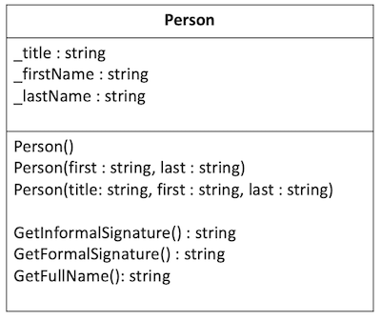Person Class Diagram

In Summary
Encapsulation is the second principle of programming with classes. A key component of encapsulation is hiding or controlling access to information. Careful use of access modifiers will help protect you and your coworkers from breaking your programs.
But also remember that Encapsulation is more than just making member variables private. Building on the principle of Abstraction, Encapsulation is all about making sure that your classes define the appropriate behaviors and then internally take care of the details needed to carry out those behaviors. Well-designed classes make careful use of constructors and provide meaningful methods for anything that needs to be done, rather than simply exposing the internal data with getters and setters.
The benefits don't stop there though. Practice encapsulation diligently and your abstractions will become more refined, your objects more purposeful, and your classes more understandable. Continue to work at it, and over time, your programs will be vastly more flexible and easy to change.

Activity Instructions
Practice the principle of encapsulation by creating classes to hold a fraction, such as 2/3. As you recall from your Math classes, a fraction has a top number (numerator) and a bottom number (denominator). The fraction can be expressed as two integers with a slash between them, such as 3/4 or as a decimal, such as 0.75.

Design the Classes
You need to create a class for a fraction that has:
- Attributes for the top and bottom numbers
- Constructors
- Getters and setters for the top and bottom numbers
- Methods to return representations of both the fractional and decimal views.
A class diagram for this class would then look as follows:
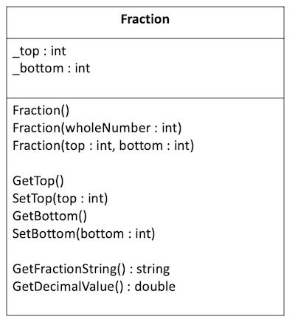Fraction Class Diagram

Start the Project
- Open the class project in VS Code.
- Navigate to the Fractions project in the week03 folder. Find the Program.cs file, which will be your entry point for the program.
- Verify that you can run the project.

Create the Fraction class
- Create a class to hold fraction.
- The class should be in its own file.
- The class should have two attributes for the top and bottom numbers.
- Make sure the attributes are private.

Create the Constructors
- Create the following constructors:
  - Constructor that has no parameters that initializes the number to 1/1.
  - Constructor that has one parameter for the top and that initializes the denominator to 1. So that if you pass in the number 5, the fraction would be initialized to 5/1.
  - Constructor that has two parameters, one for the top and one for the bottom.
- In your Program.cs file, verify that you can create fractions using all three of these constructors. For example, create an instance for 1/1 (using the first constructor), for 6/1 (using the second constructor), for 6/7 (using the third constructor).

Create the Getters and Setters
- Create getters and setters for both the top and the bottom values.
- In your Program.cs file, verify that you can call all of these methods and get the correct values, using setters to change the values and then getters to retrieve these new values and then display them to the console.

Create methods to return the representations
- Create a method called GetFractionString that returns the fraction in the form 3/4.
- Create a method called GetDecimalValue that returns a double that is the result of dividing the top number by the bottom number, such as 0.75.
- Verify that you can call each constructor and that you can retrieve and display the different representations for a few different fractions. For example, you could try:
  - 1
  - 5
  - 3/4
  - 1/3
Sample Output

1/1
1
5/1
5
3/4
0.75
1/3
0.3333333333333333

Sample Solution
When you have finished please compare your approach to the following sample solution (you may also use this sample solution as a guide if you need help finishing).

https://github.com/byui-cse/cse210-ww-student-sample-solutions

Question 1
1 / 1 pts
What is the primary goal of abstraction in programming?

To simplify a component by removing the implementation details.

To ensure that code is duplicated every where it is needed.

To optimize the performance of code.

To make a component complex enough to contain all of the detail necessary.

Question 2
1 / 1 pts
In object-oriented programming, abstraction is typically achieved using:

Loops

Classes

Conditionals

Lists

Question 3
1 / 1 pts
What is the relationship between a class and an instance?

They are two words for the same concept.

Classes are like templates. Instances are the actual objects created in memory, using that template.

Every custom class in a program is called an instance.

Instances are classes that relate to other classes.

Question 4
1 / 1 pts
Objects can contain other objects as member variables.

True

False

Question 5
1 / 1 pts
What is a method?

A member function of a class.

A custom class.

The instantiation of a class.

A member variable of a class.

Question 6
1 / 1 pts
What is encapsulation in object-oriented programming?

The technique of hiding the internal implementation details and protecting the data.

The process of creating a new object from a class.

The ability to reuse code.

The technique of combining multiple methods into a single method.

Question 7
1 / 1 pts
When we talk about information hiding in a program, who are we hiding it from?

The end user.

Potential hackers.

Other parts of the program.

Anyone on the internet.

Question 8
1 / 1 pts
Methods can call other methods.

True

False

Question 9
1 / 1 pts
Why might blindly creating getters and setters be a bad idea?

Because they are exposing the way the data is stored internally, reducing the benefits of information hiding.

Because there are so many of them that they tend to clutter up a program.

Because they are not typically used in code in industry.

Because they require so many unit tests to be created that they are not helpful.

Question 10
1 / 1 pts
In C#, if you do not define any constructors what happens?

You will not be able to instantiate the object.

It will create a default, no-argument constructor for you.

The program will not compile.

You will only be able to create one object from the class.

